- Getting started with Technology - Wireshark Analyzer.
LEARN TO USE THE PACKET SNIFFER TOOL - WIRESHARK
1.Learning objectives:
- Get acquaintance with Wireshark
  - Understand the working of Packet Sniffer (Packet Analyzer)
  - How to view and track packets?
  - How to analyze the protocols?
- Observe protocols in action
  - Run applications
  - Observe the message exchange between the protocols
  - Get acquaintance with IP header, TCP header, data link header and so on
  - Observe the contents of each field
- Getting wireshark
- Download and install the Wireshark software:
- Go to http://www.wireshark.org/download.html and download and install the
Wireshark binary for your computer.
- Download the Wireshark user guide.

Running Wireshark – sudo wireshark

- When you run the Wireshark program, the Wireshark graphical user interface shown in Figure 2 will de displayed. Initially, no data will be displayed in the various windows.
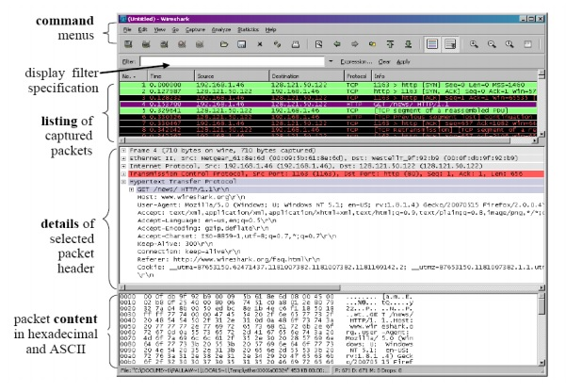
Wireshark, a network analysis tool formerly known as Ethereal, captures packets in real time and display them in human-readable format. Wireshark includes filters, color-coding and other features that let you dig deep into network traffic and inspect individual packets.

The Wireshark interface has five major components:

The command menus are standard pull-down menus located at the top of the window. Of interest to us now are the File and Capture menus. The File menu allows you to save captured packet data or open a file containing captured packet data, and exit the Wireshark application. The Capture menu allows you to begin packet capture.

The packet-listing window displays a one-line summary for each packet captured, including the packet number (assigned by Wireshark) the time at which the packet was captured, the packet’s source and destination addresses, the protocol type, and protocol-specific information contained in the packet.

The packet-header details window provides details about the packet selected (highlighted) in the packet listing window. These details include information about the Ethernet frame (assuming the packet was sent/received over an Ethernet interface) and IP datagram that contains this packet. The amount of Ethernet and IP-layer detail displayed can be expanded or minimized by clicking on the previously plus minus boxes to the left of the Ethernet frame or IP datagram line in the packet details window. If the packet has been carried over TCP or
UDP, TCP or UDP details will also be displayed, which can similarly be expanded or minimized. Finally, details about the highest level protocol that sent or received this packet are also provided.

The packet-contents window displays the entire contents of the captured frame, in both ASCII and hexadecimal format.

Towards the top of the Wireshark graphical user interface, is the packet display filter field, into which a protocol name or other information can be entered in order to filter the information displayed in the packet-listing window (and hence the packet-header and packet-contents windows)

** Analyse packets using wireshark
Use part1 and part2 files.
What you need to do ..?
1.Two application Scenarios are given to you
2.Packets captured while running these applications are provided in the form of Trace Files ( .pkafiles )
3.You need to
•analyse,
•make inferences
•answer the questions
Protocol Analysis Experiment #1 (Compulsory)
TCP –Scenario #1Reference Trace File : http-trace-1
User enters this URL and gets the following text
TCP –Scenario #1Reference Trace File : http-trace-1
User enters the second URL and gets the following text

Protocol Analysis Experiment #2 (optional)
[ Downloading a long file]
Protocols : HTTP & TCP
Application Scenario

Client requests a file from a server
Server returns the file
Nature of the file : html : Long file
Protocols to be analysed
Analyse how protocols HTTP & TCP are used in running this application. Analysis to be done in 2 parts
Part #1 : HTTP
Part #2 : TCP
Trace File to be analysed: HTTP-Tracefiles\http-trace-2

